Work Plan

(Start on 1 January 2023 and duration of 6 months)

This work plan is encompassed within the frame of the Firetec project that has the goal of, by means of detecting wildfires through the use of fiber optics networks and generating alert messages to be used in text-to-speech synthesis for later FM broadcasting in local and regional radio stations, alert the population, especially those in remote locations.

The work to be developed by David Araújo is schematized below (highlighted in blue).

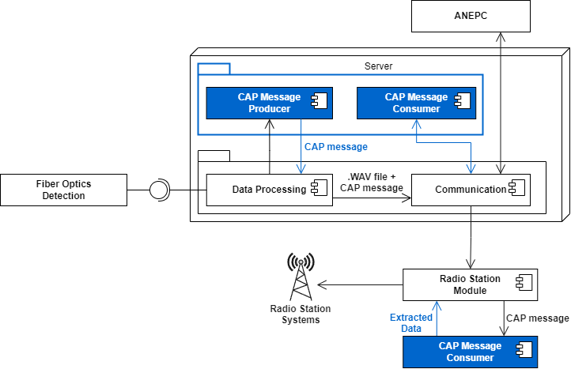

With the ultimate goal of extending the current capability with support for Common Alerting Protocol (CAP) massages, the data processing unit should have the ability of, by providing a usable set of data, construct its own CAP messages which could be used to communicate the emergency situation to the authorities (here represented by ANEPC), and to the radio station Arduino modules which are capable or interpreting them to obtain the necessary data for FM transmission.

Having said this, the work focuses mainly on the creation of a parser and deparser for CAP messages in XML format, with an API that enables any external module to write, or read, new messages.